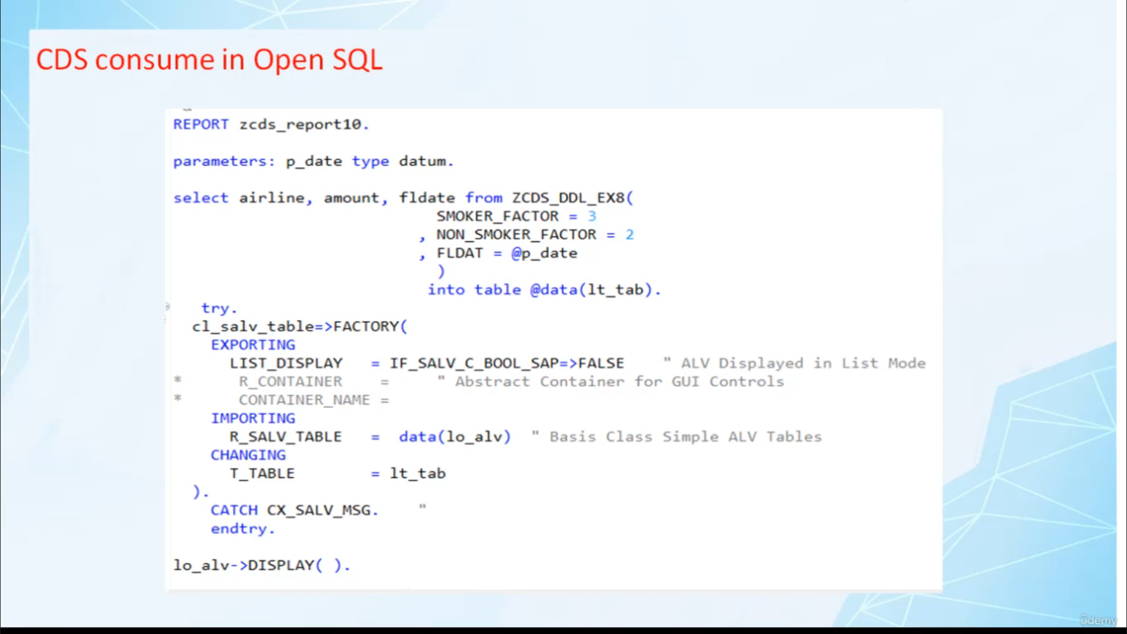

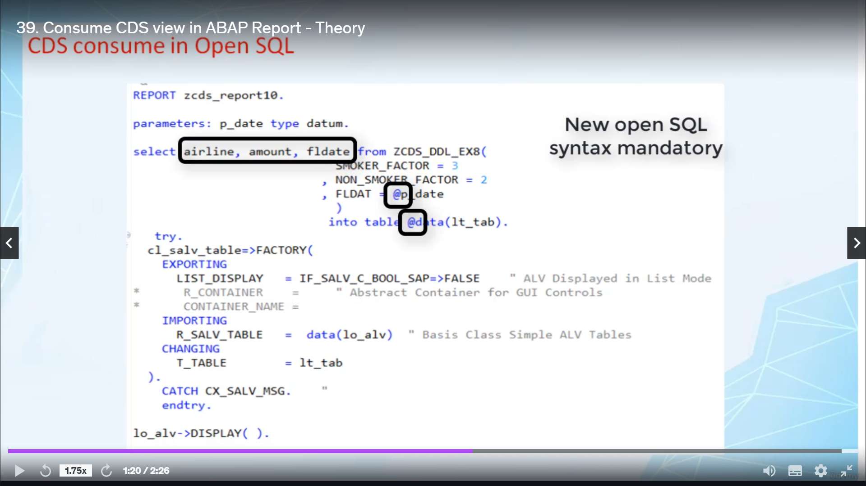

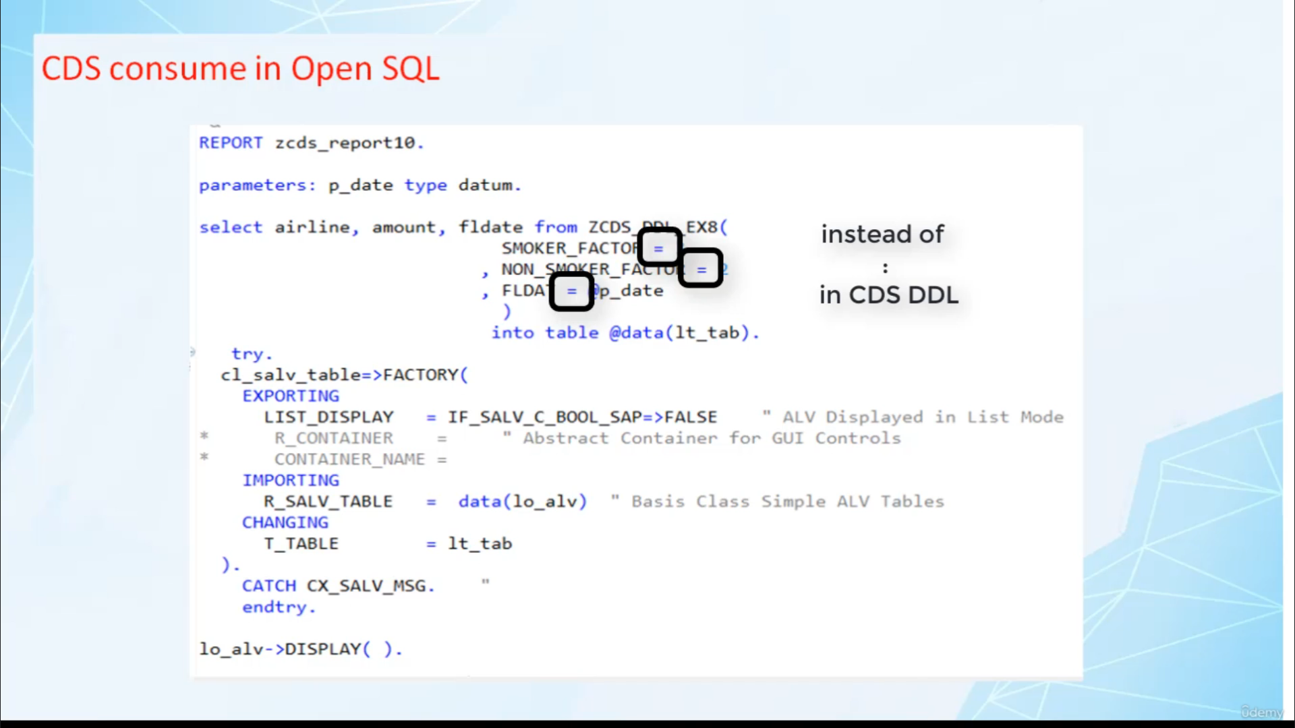

SEQUENCE DOES NOT MATTER HERE

Hi, welcome back.

In this video, I will tell you how to consume absolutist view in openness square.

We will get it when our program.

We will use one hour previously created serious view as a datasource and we will write code to read

content from this absolutist view and display the content on screen before we start coding.

Here are some important points that you should know related to a Baptist convention in Albany.

Squillari about program

point one to select data from students.

Will you see this name in different classes of openness to a select statement?

Point number two, if the front rows of a political statement contains its name, then the statement

has to follow new policies and tax rules.

That is comma separated list and use of Eskild character for Aberfeldy data objects becomes mandatory.

In openness, skrill, actual parameters for input parameters of this view are specified in parenthesized,

comma separated list.

The syntax is very similar to that using CCDs.

There are differences.

The first differences in opening school youth assignment operator.

And the second thing is the sequence of parameters does not have to match the sequence in the view definition.

So these are two main differences.

While consuming absolutism in open a school and another who.

Now, you know the basic truth related to ABC This Week on The Opening Squill, let's create one report

program and consume when I saw in that report.